Day 18 - 10th Aug 2026

Redirecting Output (> and >>)

ls > files.txt

cat files.txt

Append instead of overwrite

echo "New entry" >> files.txt

Redirecting Input (<)

echo -e "banana\napple\ncherry" > fruits.txt
-e interprets escape characters..

Redirecting Errors (2>)

ls /not_a_real_folder 2> errors.txt

Pipes (|)
ls | wc -l

Filter processes

ps aux | grep bash

Check with
Ps a
Ps au
Ps aux

Ps aux | grep bash

Multi-stage Pipeline

du -sh * | sort -rh | head -5

Du -sh *

du -sh * | sort -rh

du -sh * | sort -rh | head -5

du -sh * | sort | head -5

Silent Execution will Suppress output

./script.sh > /dev/null 2>&1

Task 1:

Sed

Go to https://www.lipsum.com/

Pick some dummy data .. and keep it in a file filename.txt

- What will this command do
Sed filename.txt

- Can you replace a word with another

S → search for 1st occurrence of any old keyword and change it with new in your file..

sed 's/old/new/' filename

- G flag → for all occurrences of the word and change it to new word.

sed 's/old/new/g' filename

- Try with delete flag
sed '/word/d' filename

- Print specific line numbers line line 3 of your file

sed -n '3p' filename

- Print range of lines

Like from line 2 to 5
sed -n '2,5p' filename

11.02 to 11.15

Task 2:

Awk (used for pattern scanning and processing)

- Now try same with awk
awk '{print}' filename

- Print specific column
awk '{print $2}' filename

- Print multiple columns
awk '{print $1, $3}' filename

- Filter rows by giving condition
Like print 1st nd 3rd column only if 3rd column value is > 50 fo example..

awk '$3 > 50 {print $1, $3}' filename

- Use custom delimiter (comma , is a delimiter operator) and print first 2 fields..

awk -F, '{print $1, $2}' filename (here f is filed separator (demiliter))

- Now count lines
awk 'END {print NR}' filename (nr is no of records..)

11.30 to 11.40 to 11.45

==========================================================================================================

Task 3:

Ping google.com

Curl https://google.com

Netstat -an

==========================================================================================================

Task 4:

Install open ssl in your system

https://www.xolphin.com/support/OpenSSL/OpenSSL_-_Installation_under_Windows#:~:text=Download%20the%20OpenSSL%20for%20Windows,file%20can%20be%20downloaded%20here.

Or

https://slproweb.com/products/Win32OpenSSL.html

Step 2 Generate a certificate signing request (CSR)

openssl genrsa -out localhost.key 2048
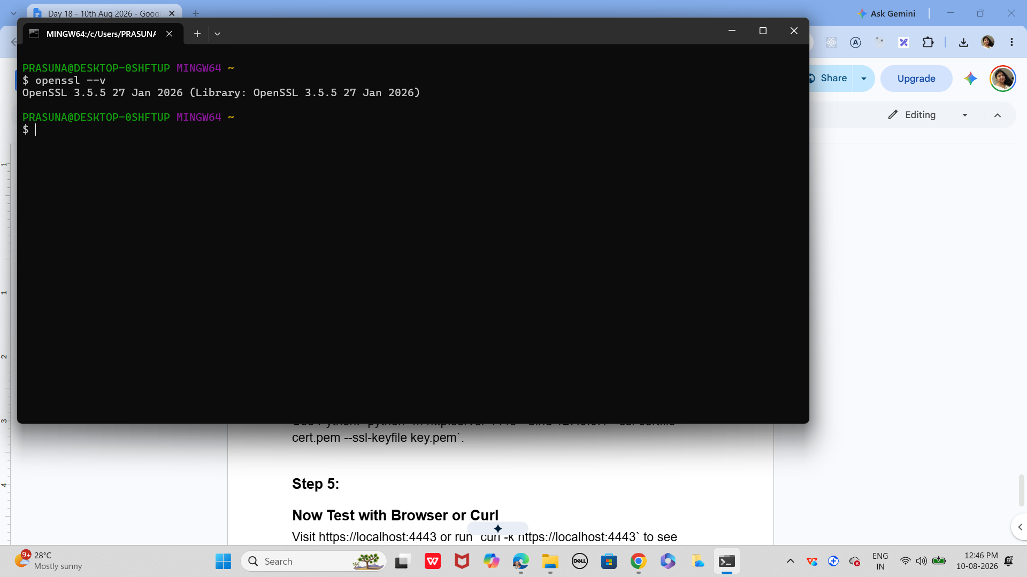

Step 3:

Generate a self‑signed certificate
In bash
openssl x509 -req -days 365 -in localhost.csr -signkey localhost.key -out localhost.crt

Step 4:

Now Start a Simple HTTPS Server
Use Python: `python -m http.server 4443 --bind 127.0.0.1 --ssl-certfile cert.pem --ssl-keyfile key.pem`.

Step 5:

Now Test with Browser or Curl
Visit https://localhost:4443 or run `curl -k https://localhost:4443` to see encrypted communication.

Step 6:

Did u Observe TLS Handshake
Use Wireshark or `openssl s_client -connect localhost:4443` to watch how TLS negotiates keys and ciphers.

Step 7:

Verify Certificate Trust
Browsers will warn about self-signed certs; in real deployments, use CA-issued certificates for trust.

—---------------------------------------------------------------------------------

Task 5:

What are trees ? where do you implement them?
2.30 to 2.33

Task 6:
Can you give types of trees?
2.34 to 2.38

Task 7:
What is binary search tree?
2.39 to 2.42

Task 8:
Can you create a simple binary tree using a node and insert values in it?

Like in java

class Node {
int val;
Node left, right;
Node(int val) { this.val = val; }
}

Insert values in left side and right side of the nodes and display the tree values
2.43 to 2.48

Task 9
Now extend the above code to search a no in your list.

2.49 to 2.53

Task 10:
Now can you do inorder traversal in your bst?
2.54 to 2.56

Task 11:
What is the fundamental difference between BFS and DFS?

2.57 to 3

task 12:
Which underlying data structures are used to implement BFS and DFS?
3.01 to 3.05

Task 13:
How do you find the shortest path in an unweighted graph?
3.06 to 3.10

task 14:
How do you detect a cycle in a graph?
3.11 to 3.15

task 15:
Explain the internal working of a HashMap.
3.16 to 3.20

Task 16:
Which property of a hashmap is used to find the intersection of two arrays?
3.21 to 3.25

Task 17:
What is collision in HashMap?
3.26 to 3.30

Task 18:
How Does Java's Capacity And Size Of Hashmap Differ?
3.31 to 3.35

Task 19:
Does hashmap allow you to store null values?
Yes, We can store as many null values in a hashmap as we want but only one null key can be stored not more than that.

Let’s see a program that depicts how we can store null values in a hashmap.

import java.util.*;
import java.io.*;
public class interviewBit {
public static void main(String[] args)
{
HashMap hmap=new HashMap();
hmap.put(1,"Program to store null value");
hmap.put(null,"InterviewBit");
System.out.println(hmap);
}
}

Can you predict the output and also explain.. I or 2 lines

3.36 to 3.40

Task 20:
hashmaps in Java are not thread-safe.can you juztify?
3.41 to 3.45

Task 21:
Can you store multiple keys with the same value in a hashmap?
3.46 to 3.50

Task 22:
can you tell the differences between a Hashmap and a Hashtable in Java.
3.51 to 3.55

Sorting Algorithms
Task 23:
Can you create a java code for bubble sort …

The snippet for your ref is given below

1. Bubble Sort
- Concept: Repeatedly swaps adjacent elements if they are in the wrong order.
- Complexity: O(n2)
- Best for: Small datasets or teaching algorithm basics.
java
for (int i = 0; i < n-1; i++)
for (int j = 0; j < n-i-1; j++)
if (arr[j] > arr[j+1])
swap(arr[j], arr[j+1]);

Visualization: Each pass “bubbles” the largest element to the end.

Task 24:
Can you create a java code for selection sort …

The snippet for your ref is given below

2. Selection Sort
- Concept: Selects the smallest element and places it at the beginning.
- Complexity: O(n2)
- Best for: Simple, predictable sorting.
java
for (int i = 0; i < n-1; i++) {
int min = i;
for (int j = i+1; j < n; j++)
if (arr[j] < arr[min]) min = j;
swap(arr[i], arr[min]);
}

Task 25:

searching Algorithms
Can you create a java code for linear search …

The snippet for your ref is given below

1. Linear Search
- Concept: Sequentially checks each element.
- Complexity: O(n)
- Best for: Unsorted or small datasets.
java
for (int i = 0; i < n; i++)
if (arr[i] == key) return i;

—----------------------------------------------------------------------------------------------------------------------------------------------------------------------------------------------------------------------------------------------------------
Home tasks:
Can you create a java code for earch of the below sort and search …

The snippet for your ref is given below

3. Insertion Sort
- Concept: Builds the sorted array one element at a time.
- Complexity: O(n2)
- Best for: Nearly sorted data.
java
for (int i = 1; i < n; i++) {
int key = arr[i];
int j = i - 1;
while (j >= 0 && arr[j] > key)
arr[j+1] = arr[j--];
arr[j+1] = key;
}

4. Merge Sort
- Concept: Divide and conquer — splits array, sorts halves, merges results.
- Complexity: O(nlog⁡n)
- Best for: Large datasets.
java
void mergeSort(int[] arr, int l, int r) {
if (l < r) {
int m = (l + r) / 2;
mergeSort(arr, l, m);
mergeSort(arr, m+1, r);
merge(arr, l, m, r);
}
}

5. Quick Sort
- Concept: Selects a pivot, partitions array around it.
- Complexity: Average O(nlog⁡n), Worst O(n2)
- Best for: Fast in practice, widely used.
java
int partition(int[] arr, int low, int high) {
int pivot = arr[high];
int i = low - 1;
for (int j = low; j < high; j++)
if (arr[j] < pivot) swap(arr[++i], arr[j]);
swap(arr[i+1], arr[high]);
return i+1;
}

Search

2. Binary Search
- Concept: Repeatedly divides sorted array in half.
- Complexity: O(log⁡n)
- Best for: Sorted data.
java
int binarySearch(int[] arr, int key) {
int low = 0, high = arr.length - 1;
while (low <= high) {
int mid = (low + high) / 2;
if (arr[mid] == key) return mid;
if (arr[mid] < key) low = mid + 1;
else high = mid - 1;
}
return -1;
}

Algorithm | Type | Time Complexity | Space Complexity | Stability
Bubble Sort | Sorting | O(n2) | O(1) | ✅
Selection Sort | Sorting | O(n2) | O(1) | ❌
Insertion Sort | Sorting | O(n2) | O(1) | ✅
Merge Sort | Sorting | O(nlog⁡n) | O(n) | ✅
Quick Sort | Sorting | O(nlog⁡n) | O(log⁡n) | ❌

